**HELMET DETECTION SYSTEM USING VISION TRANSFORMER ALGORITHM**

**MINI PROJECT REPORT**

## Submitted by

**GANESH RAJ S (Register Number: 2301507308)**

**JANARTHANAN P (Register Number: 2301507310)**

## Under the guidance of

## Dr. P. DHARANYADEVI

## ASSISTANT PROFESSOR (STC)

## Department of Computer Science and Engineering

**To the Puducherry Technological University, in partial fulfillment of the**

**requirement for the award of the degree**

## MASTER OF COMPUTER APPLICATION

## 

**DEPARTMENT OF COMPUTER SCIENCE AND ENGINEERING PUDUCHERRY TECHNOLOGICAL UNIVERSITY**

**PUDUCHERRY – 605 014**

**JANUARY - 2025**

# DEPARTMENT OF COMPUTER SCIENCE AND ENGINEERING PUDUCHERRY TECHNOLOGICAL UNIVERSITY

# PUDUCHERRY – 605 014.

**BONAFIDE CERTIFICATE**

This is to certify that the Mini Project Work titled **“HELMET DETECTION SYSTEM USING VISION TRANSFORMER ALGORITHM”** is a Bonafide work done by **GANESH RAJ S (2301507308), JANARTHANAN P (2301507310)** of **Puducherry Technological University** and that this work has not been submitted for the award of any other degree of this/any other institution.

## Staff Incharge Head of the Department

**(Dr. P. DHARANYADEVI) (Dr. E. ILLAVARASAN)**

**Submitted for University examination held on ______________________**

**Internal Examiner External Examiner**

**ACKNOWLEDGEMENT**

I am deeply indebted to **Dr. P. Dharanyadevi,** Assistant Professor(STC)**,** Department of Computer Science and Engineering, Puducherry Technological University, Pondicherry, for her valuable guidance throughout the mini project.

I also express my heart-felt gratitude to **Dr. E. Illavarasan ,** Professor & Head (CSE) for giving constant motivation in succeeding my goal.

With profoundness I would like to express my sincere thanks to **Dr. S. Mohan,** Vice Chancellor, Puducherry Technological University, for his kindness in extending the infrastructural facilities to carry out my Mini project work successfully. My sincere thanks are due to his team for facilitating every requirement for the successful completion and evaluation of our project work.

I also express my thanks to all the **Faculty** and **Technical Staff** members of the CSE department for their timely help and the **Central Library** for facilitating useful reference materials.

I would be failing in my duty if I don’t acknowledge the immense help extended by my friends, who have always been with me in all my trails and tribulations and encouraging me to complete.

**GANESH RAJ S**

**JANARTHANAN P**

**TABLE OF CONTENT**

|  |  |  |
| --- | --- | --- |
| **SL.NO** | **CONTENT** | **PAGE NO** |
|  | **ABSTRACT** |  |
|  | **LIST OF FIGURES** |  |
|  | **LIST OF TABLES** |  |
|  | **LIST OF ABBREVIATIONS** |  |
| **1.** | **INTRODUCTION**   * 1. OVERVIEW   1.1.1 MACHINE LEARNING  1.1.2 Key Concepts in Machine Learning  1.1.3 Machine Learning in Helmet Detection  1.1.4 ALGORITHM USED IN PROPOSED SYSTEM |  |
| **2.** | **LITERATURE REVIEW**  2.1 SURVEY SUMMARY  2.2 Survey of relevant work in Helmet Detection  2.3 MACHINE LEARNING IN HELMET DETECTION SYSTEM  2.4 OBJECT DETECTION TECHNIQUES AND ALGORITHM  2.5 DATASET CHALLENGES  2.6 Proposed Advantages  2.7 Existing Disadvantages  2.8 CONCLUSION |  |
| **3.** | **EXISTING WORK**  3.1 DESCRIPTION OF EXISTING WORK  3.2 YOLO ALGORITHM  3.3 ARCHITECTURAL DESIGN  3.4 MODULES IN EXISTED WORK  3.4.1 DATA PREPROCESSING  3.4.2 FEATURE EXTRACTION MODEL  3.4.3 CLASSIFICATION  3.4.4 DATASETS  3.4.5 ADVANTAGES  3.4.6 DISADVANTAGES |  |
| **4.** | **PROPOSED WORK**  4.1 DESCRIPTION OF EXISTING WORK  4.2 ViT (Vision Tranformer) Algorithm  4.3 ARCHITECTURAL DESIGN  4.4 MODULES IN EXISTED WORK  4.4.1 DATA PREPROCESSING  4.4.2 FEATURE EXTRACTION MODEL  4.4.3 CLASSIFICATION  4.4.4 DATASETS  4.4.5 ADVANTAGES |  |
| **5.** | **SIMULATION/EXPERIMENTAL RESULTS**  5.1 HARDWARE AND SOFTWARE REQUIREMENTS  5.2 IMPLEMENTATION  5.2.1 IMPORTING LIBRARIES  5.2.2 DATA PREPROCESSING  5.2.3 SPLITTING AND SCALING DATA  5.2.4 TRAINING AND EVALUATING VISION TRANSFORM ALGORITHM  5.2.5 COMPARING MODELS AND VISUALIZING ACCURACY  5.3 EVALUATION METRICS |  |
| **6.** | **CONCLUSION** |  |
| **7.** | **REFERENCES** |  |

**HELMET DETECTION SYSTEM USING VISION TRANSFORMER ALGORITHM**

**ABSTRACT**

Ensuring road safety, particularly for motorcyclists, is a critical global concern. One effective measure to enhance safety for riders is the use of helmets, which significantly reduces the risk of severe head injuries in accidents. However, enforcing helmet usage can be challenging due to limited resources for manual monitoring and enforcement. This project aims to develop an automated helmet detection system using an improved version of the YOLO V8 (You Only Look Once) object detection algorithm, tailored for real -time helmet recognition.

By optimizing YOLO V8, the system achieves high accuracy in detecting whether a motorcyclist is wearing a helmet, even in varied and challenging conditions, such as poor lighting, occlusion, or varying helmet colors. The project involves the design, training, and deployment of a neural network model enhanced with specific improvements over the base YOLO V8 architecture to boost its robustness and speed. The system is designed to be integrated into real-world applications, such as surveillance cameras at traffic intersections, where it can continuously monitor and identify helmet usage among motorcyclists.

The proposed solution addresses the limitations of previous models by improving detection rates, reducing false positives, and enhancing computational efficiency, making it suitable for large-scale deployment. The results demonstrate that the improved YOLO V8 model achieves a significant increase in both detection accuracy and processing speed compared to previous versions, proving it to be an effective tool for enforcing helmet compliance in real time. This project contributes to the field of traffic safety automation and has the potential to assist traffic authorities in ensuring compliance with helmet-wearing regulations, ultimately reducing fatalities and injuries among motorcyclists.

**LIST OF FIGURES**

|  |  |  |
| --- | --- | --- |
| **FIG.NO** | **TITLE** | **PAGE NO** |
| **1.1** | Helemt Detection |  |
| **1.2** | Supervised learning |  |
| **1.3** | Unsupervised learning |  |
| **1.4** | System architecture existing |  |
| **1.5** | System architecture proposed |  |
| **1.6** | Bar Graph Comparing Model Accuracies |  |

**LIST OF ABBREVIATIONS**

1. **ML** - Machine Learning
2. **AI -** Artificial Intelligence
3. **YOLO V8** - You Only Look Once
4. **ViT** - Vision Transformer
5. **CNN** - Convolutional Neural Network
6. **R-CNN** - Region-based CNN
7. **SVM** - Support Vector Machine
8. **RPN -** Region Proposal Networks
9. **FPN -** Feature Pyramid Networks
10. **PCA -** Principal Component Analysis
11. **TP** - True Positives
12. **TN** - True Negatives
13. **FP** - False Positives
14. **FN** - False Negatives

**CHAPTER 1**

1. **INTRODUCTION**
   1. **OVERVIEW**

An efficient traffic management system must include continuous monitoring of vehicle compliance with traffic laws. In densely populated urban areas of India, motorcycles are a primary mode of transport. However, a significant number of motorcyclists often neglect to wear helmets, thereby compromising both safety and adherence to traffic regulations. To address this issue, a YOLOv8-based helmet detection system can be implemented to automatically identify and monitor helmet usage. This real-time monitoring system can help ensure compliance, enhance road safety, and reduce the risk of accidents, ultimately improving the overall efficiency of traffic regulation in urban environments[1].

The helmet detection system, powered by YOLOv8, is essential for ensuring the safety of motorcyclists. Given that motorcycle accidents often lead to severe head injuries, this system helps identify whether a rider is wearing a helmet or not. By utilizing advanced computer vision and real-time processing, YOLOv8 can detect helmets with high accuracy, providing immediate feedback to authorities or safety enforcement systems[2]. Implementing such a system can promote helmet usage and contribute to preventing life-threatening injuries. It offers a significant technological step forward in enhancing road safety, especially in areas where helmet laws are mandatory for all riders.

The growing concern regarding accidents and injuries associated with motorcycle use, particularly due to the non-compliance of riders with helmet-wearing regulations, has escalated. The rise in motorcycle traffic has made it more challenging to ensure road safety, with helmet non-compliance being a significant factor contributing to severe injuries during accidents[3]. Currently, authorities rely on manual checks and video surveillance from cameras placed at intersections to enforce helmet laws. These methods are labor-intensive, time-consuming, and prone to human error.

To address these challenges, a more efficient and accurate solution is the development of a computer vision system using YOLOv8 (You Only Look Once version 8) to automatically detect riders who are not wearing helmets. This system would leverage the power of YOLOv8 to analyze real-time surveillance footage and identify motorcyclists based on visual features such as movement patterns, shape, and helmet detection. YOLOv8’s speed and accuracy would enhance the ability to detect helmet violations in a fraction of the time it takes with manual checks, improving overall road safety and enforcement[4]. By utilizing this advanced deep learning model, the system can classify moving objects, identifying motorcycles and distinguishing riders without helmets, thereby helping authorities to improve helmet law compliance effectively.

The system leverages YOLOv8, known for its superior real-time object detection capabilities, enabling the automatic identification of individuals adhering to safety protocols by wearing helmets. YOLOv8’s advanced deep learning architecture ensures high accuracy and speed, making it ideal for processing static images and real-time video streams. With OpenCV’s robust image processing features, the system is adaptable across various platforms and environments[5].

Handling a substantial amount of data within time constraints is a significant challenge in real-time applications. Tasks like segmentation[6], feature extraction, classification, and tracking demand high computational efficiency to ensure smooth implementation. YOLOv8 addresses these challenges through its streamlined architecture, enhancing detection accuracy while maintaining scalability.

The helmet detection system, based on YOLOv8, faces a limitation where motorcycles are detected only from a side view. This restricts the ability to capture or recognize the number plate, making it impossible to officially identify the violator. Consequently, the system's enforcement capabilities are hindered. Vehicle classification, such as distinguishing between motorcycles, cars, trucks, etc., is accomplished using advanced algorithms[7]. However, the inability to detect the number plate in side-view detection limits the system’s potential for automatic violation identification, emphasizing the need for improvements in capturing frontal or rear views for comprehensive enforcement.

The integration of machine learning and OpenCV in helmet detection minimizes human effort, reduces error, and ensures precise compliance monitoring.[8] This technology not only automates safety oversight but also provides immediate feedback, reducing reliance on manual supervision and significantly improving adherence to safety regulations. Its scalable nature enables deployment in diverse settings, promoting proactive safety measures that minimize risks and save lives[9].

The proposed YOLOv8-based Helmet Detection System automates the identification of motorcyclists not wearing helmets by analyzing real-time footage from surveillance cameras[10]. This approach ensures higher accuracy and efficiency in detecting non-compliance. The system classifies moving objects as motorcycles or other vehicles using features extracted from their regional properties. YOLOv8’s precise classification capabilities allow for improved recognition of motorcycles and individuals without helmets[11].

The initial step in identifying moving vehicles involves detecting helmets. This process begins by analyzing the first video frame, separating the background from moving objects rather than processing the entire video at once.[12] Processing only the initial frames simplifies the procedures required for video analysis. Establishing a Gaussian mixture model for foreground detection demands a specific number of frames, though noise often affects the results. Subsequently, bounding boxes are generated for connected components representing moving vehicles.[13]

Helmet detection leverages a similar approach used for vehicle classification. Two-wheeler images, cropped to highlight the rider's head region, train the helmet detector[14]. Maintaining class balance during training ensures an equal representation of images with and without helmets. Various machine learning classifiers are evaluated to identify the most effective one. The absence of helmets significantly increases the risk of severe injury or death in high-speed collisions[15]. Helmets mitigate impact forces, potentially saving lives.

* + 1. **MACHINE LEARNING**

Machine Learning is a subfield of Artificial Intelligence (AI) that focuses on developing algorithms and statistical models that allow computers to learn from and make decisions or predictions based on data. Unlike traditional programming, where explicit instructions are provided, machine learning systems are trained on data to identify patterns and relationships, enabling them to make predictions or decisions without being explicitly programmed.

Machine learning can be broadly categorized into three types:

**Supervised Learning**:

In supervised learning, the algorithm is trained on a labelled dataset, meaning the input data is paired with the correct output. The goal is to learn a mapping from inputs to outputs so that the model can make accurate predictions on new, unseen data. Examples include regression and classification tasks.

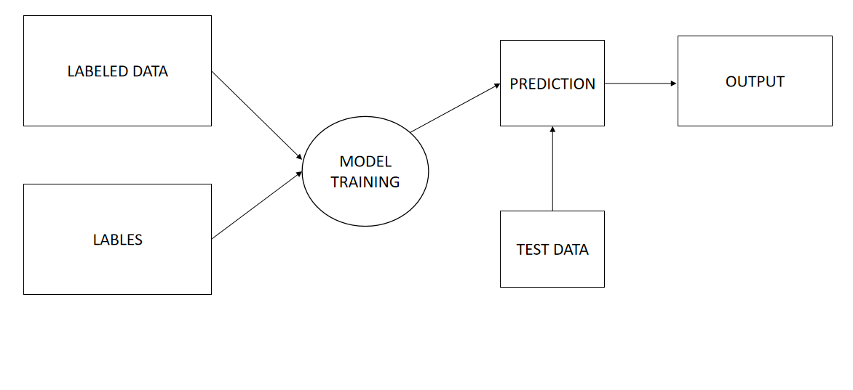

**Figure 1.1 Supervised Learning**

Figure1.1 illustrates the process of supervised learning, from inputting labeled data to producing the desired output.

**Unsupervised Learning**:

This type of learning involves training the algorithm on data without labelled outputs. The system tries to identify patterns, structures, or relationships in the data. Examples include clustering and dimensionality reduction.

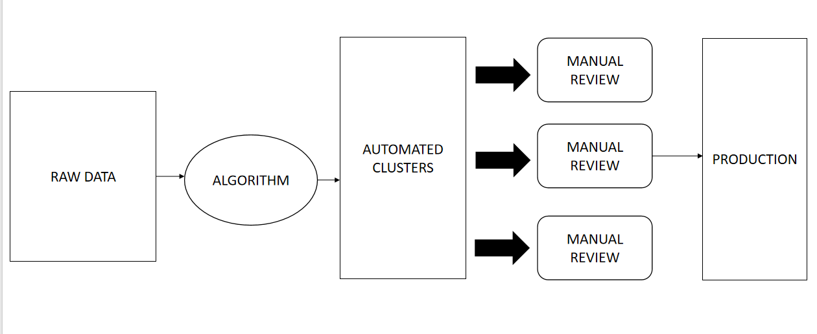**Figure 1.2 Unsupervised Learning**

Figure 1.2 illustrates the process of unsupervised learning from inputting raw data to producing the output.

**1.1.2 Key Concepts in Machine Learning**

Machine learning involves several key concepts that are fundamental to understanding and building models. One of the primary processes is training and testing, where a model is trained using a subset of data, known as the training set, to learn patterns and relationships. The performance of this trained model is then evaluated on a separate subset of data, called the testing set, to ensure it can generalize well to unseen data. This separation is crucial to avoid overfitting, where the model performs well on the training data but poorly on new data.Another essential concept in machine learning is the distinction between features and labels. Features are the input variables that provide information for the model to analyze, such as numerical values, categories, or textual data. Labels, on the other hand, are the target outcomes the model aims to predict. For instance, in an image classification task, features could include pixel values of images, while labels represent the categories being predicted, such as "with helmet" or "without helmet." Together, these concepts form the basis of machine learning workflows, enabling the creation of models that can extract insights, make predictions, and solve complex problems across various domains.

**1.1.3 Machine Learning in Helmet Detection**

Helmet detection involves analysing image data to determine whether motorcyclists are wearing helmets. Machine learning is particularly well-suited for this task because of its ability to:

* Handle large image datasets with multiple features.
* Capture complex patterns and variations in image data.
* Improve prediction accuracy through advanced techniques like Convolutional Neural Network and ensemble learning.

**1.1.4 ALGORITHMS USED IN THE PROPOSED STUDY**

**Vision Transform:**

* **Vision Transformer (ViT):** A Vision Transform is a transformer-based deep learning model that processes images for classification and object detection tasks. It divides the input image into patches, embeds them, and processes the sequence of patches using a transformer architecture to learn global and local patterns.
* **Advantages:**

* Efficient in capturing long-range dependencies and contextual information.

* Handles large datasets effectively with minimal inductive bias.

* Provides state-of-the-art accuracy in image classification tasks.

* **Limitations:**

* Requires large amounts of data for training.

* Computationally intensive compared to CNN-based methods.

* Sensitive to small changes in the dataset.

**CHAPTER 2**

**2. LITERATURE SURVEY**

**2.1 SURVEY SUMMARY**

|  |  |  |  |  |
| --- | --- | --- | --- | --- |
| **S.No** | **Author(s)** | **Methodology** | **Pros** | **Cons** |
| **1.** | A. Mehta et al. | YOLOv8 for Traffic Safety | High precision and speed; robust detection under challenging conditions. | May require large annotated datasets for training. |
| **2.** | 1. Sharma and   K. Patel | Real-Time Helmet Detection Using YOLOv8 | Real-time processing; robust performance in urban traffic settings. | Computationally expensive for resource-constrained devices. |
| **3.** | 1. Kumar and   L. Reddy | Comparative Analysis of YOLO Models for Detection | Detailed evaluation of YOLO versions; highlights YOLOv8's advantages in accuracy and speed. | Focuses less on practical deployment strategies. |
| **4.** | 1. Verma and   N. Singh | Hybrid Approach Using YOLOv8 and Image Enhancements | Enhanced detection under poor conditions; more accurate results with preprocessing. | Hybrid systems may require additional computational resources. |
| **5.** | K. Jain and A. Gupta | Survey on Helmet Detection Techniques | Highlights advancements in YOLOv8; explores future integration opportunities. | Limited in-depth focus on specific practical use cases. |
| **6.** | M. Bose and T. Roy | Real-Time Helmet Detection for Smart Cities | Integration with IoT-enabled systems; scalable for large-scale traffic monitoring. | Requires large infrastructure and high initial investment |

**2.2 Survey of relevant work in Helmet Detection**

**Paper:** 01

**Title:** "Helmet Detection Using YOLOv8 for Traffic Safety"

**Author:** A. Mehta et al.

**Year:** 2023

**Description:** This paper presents a helmet detection system using YOLOv8 to enhance traffic safety by identifying motorcyclists not wearing helmets in real-time. The study highlights YOLOv8's advanced object detection capabilities, leveraging its high precision and speed. The authors explain the dataset preparation process, which includes annotated images of motorcyclists in various environments. The paper emphasizes the system's ability to detect helmets under challenging conditions, such as occlusion and low lighting, and provides detailed performance metrics showcasing its efficacy in real-world scenarios.

**Advantages:**

* Using YOLOv8 ensures high-speed processing, making the system capable of real-time helmet detection, crucial for immediate traffic law enforcement.
* YOLOv8's advanced object detection algorithms allow for high precision in detecting helmets, even in crowded or complex scenes.
* By identifying motorcyclists without helmets, the system can aid in reducing fatalities and injuries, contributing to public safety.

**Disadvantages:**

* Despite YOLOv8's accuracy, there may still be instances of false detections, such as misclassifying a head covering as a helmet or failing to detect a helmet in unusual conditions.
* While the system is robust, extreme conditions like heavy rain, fog, or glaring sunlight can still degrade performance.
* Periodic updates to the dataset and model retraining may be necessary to adapt to new helmet designs or evolving traffic conditions.

**Paper:** 02

**Title:** "Real-Time Helmet Detection Using YOLOv8 in Urban Traffic"

**Author:** P. Sharma and K. Patel

**Year:** 2024

**Description:** This study introduces a real-time helmet detection system based on YOLOv8, aimed at improving road safety in urban traffic settings. By training YOLOv8 on a large-scale, diverse dataset, the model achieves remarkable accuracy in identifying motorcyclists with and without helmets. The paper discusses the system's deployment on edge devices, enabling real-time monitoring without requiring extensive computational resources. The authors also analyze the model's robustness in detecting helmets amidst heavy traffic and varying weather conditions.

**Advantages:**

* The system can help improve road safety by identifying motorcyclists not wearing helmets, potentially reducing head injuries and fatalities in traffic accidents.
* Deployment on edge devices allows for immediate detection, making it suitable for applications requiring low latency, such as traffic monitoring and law enforcement.
* The use of YOLOv8, combined with a large-scale, diverse dataset, ensures precise detection even in complex urban traffic scenarios.

**Disadvantages:**

* Continuous surveillance and real-time monitoring might raise privacy concerns among citizens, especially if personal data is not adequately protected.
* While the model is optimized for edge devices, its performance may still be constrained by the computational capabilities of the deployed hardware.
* Using automated systems for enforcement could raise legal questions about accountability and the fairness of penalties issued based solely on AI detection.

**Paper:**  03

**Title:** "Comparative Analysis of YOLOv8 and Prior YOLO Models for Helmet Detection"

**Author:** S. Kumar and L. Reddy

**Year:** 2023

**Description:** This research compares YOLOv8 with earlier YOLO versions for the task of helmet detection in traffic surveillance. The authors provide a detailed evaluation of detection accuracy, speed, and generalization capability across different YOLO architectures. The study demonstrates YOLOv8's superior performance in detecting helmets with higher precision and reduced false positives. Additionally, the paper highlights the challenges posed by diverse datasets and the role of model optimization in achieving real-time processing.

**Advantages:**

* The advancements in YOLOv8 could enable better detection of small and partially occluded helmets, which is a common challenge in real-world surveillance footage.
* YOLOv8 could be more easily deployable on different hardware platforms, making it adaptable to a range of devices, from edge computing devices to cloud-based processing systems.
* Due to improvements in architecture, YOLOv8 could require less time to train or fine-tune compared to earlier models, which might need more epochs for convergence.

**Disadvantages:**

* YOLOv8, with its improvements, might come with a larger model size, which could be a limitation when deploying on resource-constrained systems such as embedded devices or mobile phones.
* While YOLOv8 offers improved performance, it may require higher computational resources than earlier versions, particularly in terms of memory and processing power, which could be a limitation in low-resource environments.
* Achieving optimal performance with YOLOv8 might require more advanced hyperparameter tuning and expertise, which could limit its accessibility for users with less technical experience.

**Paper:** 04

**Title:** "Hybrid Approach for Helmet Detection Using YOLOv8 and Image Enhancement Techniques"

**Author:** R. Verma and N. Singh

**Year:** 2024

**Description:** This paper proposes a hybrid helmet detection system that combines YOLOv8 with image enhancement techniques to improve detection accuracy under adverse conditions such as poor lighting and motion blur. The authors detail the preprocessing steps, including noise reduction and contrast enhancement, which significantly enhance YOLOv8's detection performance. The study also covers the system's deployment in smart traffic monitoring systems, demonstrating its ability to operate effectively in real-world scenarios.

**Advantages:**

* The hybrid approach improves helmet detection accuracy, particularly in challenging conditions like low lighting and motion blur.
* The system is highly applicable to smart traffic monitoring, enabling real-time, effective helmet detection.

**Disadvantages:**

* The image enhancement techniques may introduce computational overhead, affecting real-time processing.
* The system's performance might degrade in highly dynamic environments with extreme motion or severe weather conditions.

**Paper:** 05

**Title:** "A Survey on Helmet Detection Techniques: YOLOv8 and Beyond"

**Author:** K. Jain and A. Gupta

**Year:** 2023

**Description:** This review paper provides a comprehensive survey of helmet detection techniques, focusing on YOLOv8's advancements and its comparison with traditional and modern approaches. The authors discuss the evolution of helmet detection models, from classical machine learning algorithms to deep learning-based methods like YOLO. The study examines the strengths and weaknesses of YOLOv8, particularly its ability to detect small objects with high accuracy, and explores the future potential of integrating YOLOv8 with other technologies for enhanced detection systems.

**Advantages:**

* YOLOv8 offers superior accuracy in detecting small objects like helmets, enhancing safety measures.
* The model's speed and efficiency make it ideal for real-time applications.
* Integration with other technologies could lead to more advanced and reliable helmet detection systems.

**Disadvantages:**

* YOLOv8 may require large datasets for optimal performance, limiting its adaptability in some regions.
* The model might face challenges in detecting helmets under diverse environmental conditions.
* It could be computationally expensive for devices with limited processing power.

**Paper:** 06

**Title:** "Real-Time Helmet Detection System for Smart Cities Using YOLOv8"

**Author:** M. Bose and T. Roy

**Year:** 2024

**Description:** This paper presents a real-time helmet detection system designed for smart city applications, utilizing YOLOv8 for its high-speed and accurate detection capabilities. The authors describe the integration of the detection system with IoT-enabled traffic cameras, allowing for automated identification of motorcyclists without helmets. The study highlights the system's scalability, its ability to process large volumes of data, and its role in promoting traffic safety through efficient law enforcement mechanisms.

**Advantages:**

* High Accuracy & Speed: YOLOv8 enables rapid and precise helmet detection, ensuring real-time monitoring of traffic.
* Scalability: The system can be easily integrated into existing IoT infrastructure, making it adaptable to various smart city environments.
* Improved Traffic Safety: Automated helmet detection enhances law enforcement efficiency, reducing the risk of accidents and promoting safety.

**Disadvantages:**

* Dependency on Camera Quality: The effectiveness of the system may be hindered by low-quality traffic cameras or poor lighting conditions.
* Privacy Concerns: Continuous monitoring might raise concerns about surveillance and individual privacy.
* High Computational Load: Processing large volumes of data in real-time could require significant computational resources, especially for large cities.

**2.3 Machine Learning in Helmet Detection**

Helmet detection systems have been a subject of study in various research fields, particularly within traffic safety and automated surveillance. Traditionally, helmet detection was manually enforced by law enforcement or through visual inspection via surveillance cameras. However, with the rise of machine learning and computer vision technologies, automated systems have become more viable. Various existing systems focus on identifying helmets using image classification, object detection, and deep learning techniques. Early methods, such as Support Vector Machines (SVM) and Haar cascades, faced limitations due to poor performance in diverse environmental conditions, like lighting variations or occlusions. Recent advancements in deep learning, particularly convolutional neural networks (CNNs) and object detection models, have led to more accurate and scalable solutions.

**2.4 Object Detection Techniques and Algorithms**

Object detection algorithms are pivotal in identifying and classifying objects within images and videos. Traditional object detection approaches like sliding windows and region-based CNNs (R-CNN) were computationally expensive and slow. However, newer models such as YOLO (You Only Look Once) and Faster R-CNN significantly improved both speed and accuracy by using real-time object detection techniques. YOLO, in particular, stands out for its ability to process images in real-time while maintaining high accuracy. Unlike traditional methods, YOLO detects multiple objects in a single forward pass, making it faster and more efficient, which is crucial for real-time applications like helmet detection in traffic monitoring.

**2.5 Dataset Challenges**

Meteorological datasets often contain missing or incomplete data, which can impact model performance. Several preprocessing techniques, including imputation and feature scaling, have been proposed to address these challenges. For example, studies suggest that normalizing features such as temperature, humidity, and pressure improves model convergence and accuracy.

**2.6 Proposed Advantages**

**1**.**Captures Global and Local Features:**

ViT processes images as sequences of patches, enabling the model to capture both local and global patterns. This is particularly beneficial for complex detection tasks like helmet identification, where both fine-grained details and broader context are important for accurate detection.

**2.Better Performance on Large Datasets:**

ViT has demonstrated superior performance on large datasets, especially in comparison to traditional convolutional neural networks (CNNs). It benefits from the transformer architecture's scalability, which allows it to handle large amounts of training data and learn complex features more efficiently.

**3.Scalability and Flexibility:**

The transformer architecture behind ViT is highly scalable and flexible, allowing it to work across different sizes of images and datasets. As more data becomes available, ViT can adapt and improve, making it well-suited for real-time applications like traffic surveillance where data is continuously being collected.

**4.Transfer Learning Capabilities:**

ViT excels in transfer learning, where pre-trained models on large datasets can be fine-tuned for specific tasks, like helmet detection. This reduces the need for massive amounts of labeled data for every new task, improving efficiency and saving computational resources.

1. **Improved Detection Accuracy:**

With its ability to learn fine-grained features and handle complex patterns in the data, ViT improves the overall detection accuracy. This is critical for safety-critical applications like helmet detection, where false positives and false negatives need to be minimized.

**2.7 Existing Disadvantages**

1. **Complexity of Model Architecture:**

YOLOv8's advanced deep learning architecture offers significant improvements over traditional methods, but its complexity can demand high computational resources. Training requires specialized hardware like GPUs or TPUs, which may not be available in all environments. This poses a challenge for resource-constrained systems, limiting its accessibility.

1. **Dependency on Large Annotated Datasets:**

Training YOLOv8 requires a large, diverse set of annotated data to achieve high detection accuracy. Collecting and labeling this data can be time-consuming and costly. Inadequate or low-quality data can significantly hinder the model’s performance, especially in specialized tasks, requiring considerable investment in data preparation.

1. **Challenges in Handling Severe Occlusions:**

Despite advancements, YOLOv8 may still struggle with severe occlusions, where objects block key features of the helmet. In highly cluttered environments, detecting partially hidden helmets becomes more difficult, resulting in lower accuracy. This limitation can reduce the model's effectiveness in real-world scenarios with frequent occlusions.

1. **Real-Time Processing Constraints:**

YOLOv8's real-time detection performance can be affected by the input image's size and complexity. Larger images or more complex scenes may introduce processing delays, especially if computational resources are limited. This results in latency, which is a critical drawback for time-sensitive applications requiring immediate detection and response.

1. **Overfitting Risk with Limited Data:**

In cases where the training dataset is small or lacks diversity, YOLOv8 may overfit, leading to poor generalization on unseen data. The model will perform well on familiar data but struggle with variations like helmet design, environmental conditions, or unexpected scenarios, reducing its overall reliability and robustness.

1. **Limited Adaptability in Extreme Cases:**

YOLOv8 may not perform optimally in cases where the helmet design or environmental factors differ significantly from those seen during training. For rare or unique helmet types, the model might fail to recognize them accurately. Expanding the dataset or employing data augmentation techniques could mitigate this issue.

**2.8 Conclusion**

This literature review highlights the evolution of helmet detection methods, from traditional manual monitoring and rule-based systems to advanced machine learning techniques. It underscores the need for systematic evaluations of different algorithms to determine their suitability for specific datasets and real-world applications. By addressing these gaps, the current study aims to provide insights into the comparative performance of Convolutional Neural Networks (CNNs) and Support Vector Machines (SVMs) for helmet detection.

**CHAPTER 3**

**3. EXISTING SYSTEM**

**3.1 Description of Existing Work**

Helmet detection systems have traditionally relied on classical image classification models or basic machine learning techniques, such as Support Vector Machines (SVMs), which primarily utilize image features like shape, color, and texture to determine whether a motorcyclist is wearing a helmet. While these methods have proven functional in controlled environments, they face significant challenges when applied to real-world scenarios. One of the key limitations is their inability to effectively handle the complexity of non-linear features in image data, such as variations in lighting, occlusion, diverse helmet designs, and differences in rider appearances. This reduces their robustness and accuracy in dynamic conditions. Additionally, these traditional systems often encounter scalability issues as dataset sizes grow. Their reliance on computationally intensive processes makes them inefficient for real-time applications, where fast and accurate detection is critical. Furthermore, the lack of sophisticated feature extraction techniques limits their ability to adapt to diverse conditions, such as changes in environment or variations in camera angles, which are common in real-world settings. Modern deep learning approaches, such as YOLO (You Only Look Once) v8, offer a significant improvement over traditional methods. YOLO's advanced architectures enable real-time object detection with high accuracy by leveraging pre-trained models and end-to-end learning frameworks. These methods are more effective at capturing complex, non-linear relationships in image data and can scale better with larger datasets. Despite these advancements, many existing helmet detection models have yet to fully exploit the capabilities of deep learning, leaving ample room for improvement in terms of detection accuracy, computational efficiency, and adaptability to diverse conditions.

**3.2 YOLO Algorithm**

This code implements a system for detecting whether people are wearing helmets in a video or image using a custom-trained YOLO (You Only Look Once) object detection model. YOLO is a popular deep learning model used for detecting objects in real-time. The main goal of the code is to identify and mark people in a video or image who are wearing helmets versus those who are not.

Similarity Formula:

Bounding Box Calculation:

Width of box (w): w = x2 - x1

Height of box (h): h = y2 - y1

Confidence Score Formula:

Confidence Score (conf): conf = math.ceil((box.conf[0] * 100)) / 100 This rounds the confidence score to two decimal places for better readability.

**3.3 System Architectural Design**

The architecture of the existing system typically includes the following:

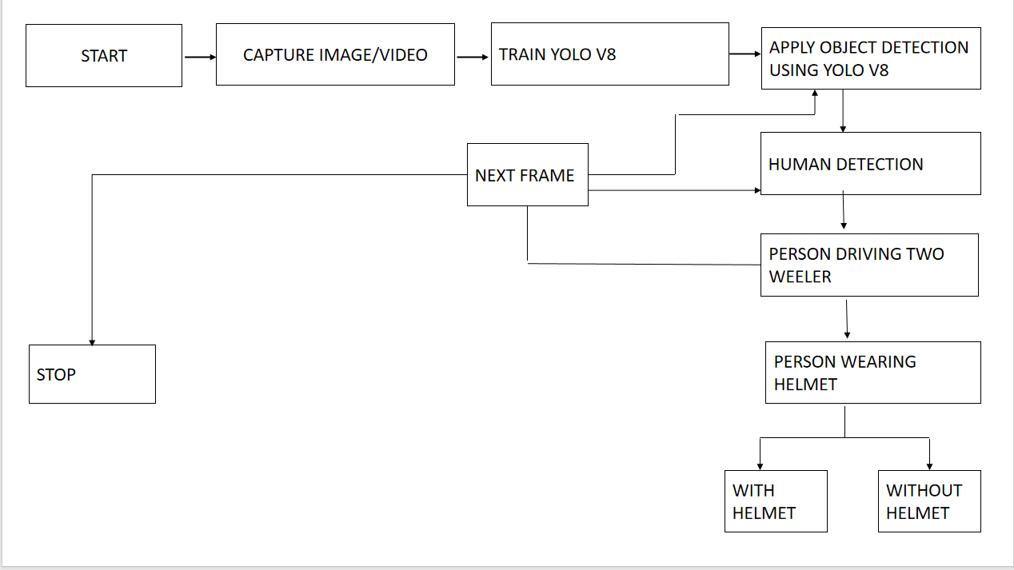

**Figure 1.3 System architecture existing**

Figure 1.3 Represents a process flow for using YOLOv8 approach.This shows the flow , how data is transformed into meaningful through features analysis.

**3.4 Modules in Existing Work**

The existing system is typically divided into the following modules:

**3.4.1 Data Preprocessing**

Effective data preprocessing is crucial for ensuring that a YOLOv8 model can learn meaningful patterns from raw data. This process begins with image normalization, where pixel values are scaled to a standard range, typically between 0 and 1. Normalizing images ensures that the neural network processes inputs uniformly, improving the stability and efficiency of the training process. Another important step is data augmentation, which enhances the diversity of the training dataset. Techniques like rotation, flipping, cropping, and color jittering simulate variations in real-world scenarios, enabling the model to generalize better to different conditions, such as changes in lighting, camera angles, and object occlusions. Additionally, resizing input images to standard dimensions, such as 640x640 or 416x416 pixels, ensures compatibility with the YOLOv8 model’s architecture. This resizing step balances computational efficiency with model performance, allowing the network to process data effectively. By combining these preprocessing techniques, the training data becomes more robust, helping the YOLOv8 model achieve improved accuracy and adaptability in detecting and classifying objects across diverse environments.

**3.4.2 Feature Extraction Model**

YOLOv8 uses advanced deep learning techniques for effective feature

extraction in helmet detection. By leveraging convolutional neural networks

(CNNs), it automatically learns features at different abstraction levels, such

as edges, textures, and object components, which are essential for accurate

identification. The model incorporates an enhanced region proposal

mechanism to suggest potential bounding boxes for helmets, focusing on

key image areas based on learned patterns. Additionally, it integrates

Feature Pyramid Networks (FPNs) to improve detection across various

scales and resolutions. This capability allows the model to identify helmets

of different sizes, ensuring robustness in diverse real-world conditions.

Together, these features enable YOLOv8 to perform precise and scalable

helmet detection, making it suitable for applications requiring high

accuracy in complex and dynamic environments

**3.4.3 Classification**

YOLOv8 is a versatile object detection model capable of both classifying objects and localizing them by predicting bounding boxes, making it highly effective for detecting helmets in various contexts. Beyond basic helmet detection, it supports multi-class classification, enabling differentiation between types of helmets, such as full-face, half-face, and open-face, depending on the training dataset. Designed for high-speed inference, YOLOv8 is well-suited for real-time applications like traffic monitoring and helmet compliance enforcement, offering rapid and accurate results. Its efficiency in combining classification and localization ensures minimal computational delay, making it an ideal choice for time-sensitive detection tasks

**3.4.4 Datasets**

Helmet detection datasets play a crucial role in training models for robust performance. Public datasets, such as the "Helmet Dataset," provide annotated images of motorcyclists with and without helmets, capturing variations in lighting, backgrounds, and occlusions. Training on diverse datasets enhances YOLOv8's ability to detect helmets across various conditions, including different camera angles, weather, and times of day. Additionally, synthetic datasets generated through simulations or data augmentation techniques can supplement real-world data, addressing rare scenarios and uncommon helmet types. This combination of real and synthetic data ensures the model is robust and adaptable to real-world applications.

**3.4.5 Advantages**

1. **Real-Time Detection:**

YOLOv8's real-time object detection capability ensures quick processing and accurate identification of helmets in dynamic environments. This is especially useful for traffic monitoring, safety enforcement, and surveillance, where timely detection is critical. Its efficiency in detecting helmets without delay makes it a valuable tool in monitoring public spaces or workplaces, contributing to increased safety in real time.

1. **High Accuracy:**

The YOLOv8 model incorporates advanced feature extraction and deep learning techniques, delivering exceptional detection accuracy. It handles complex environments, varying lighting conditions, diverse camera angles, and partial occlusions without compromising performance. This accuracy is vital in critical applications like helmet detection, ensuring reliable results and minimizing false positives or negatives in real-world, unpredictable scenarios.

1. **Scalability:**

YOLOv8 can effectively manage large datasets, outperforming traditional machine learning models that struggle with scalability. Its ability to process vast amounts of data quickly and efficiently makes it ideal for applications requiring continuous learning, such as real-time helmet detection in traffic or industrial environments. This scalability ensures that the model adapts to evolving data and remains robust over time.

1. **Multi-Class Classification:**

YOLOv8's ability to perform multi-class classification adds versatility to helmet detection. Not only does it detect helmets, but it can also differentiate between various types, such as full-face, half-face, or open-face helmets. This is particularly useful in safety enforcement or workplace environments where identifying the type of helmet can be important for compliance or risk assessment.

1. **Efficient Resource Utilization:**

YOLOv8 optimizes computational resources by performing both object detection and classification in a single pass. This ensures that the model delivers real-time results with minimal delay, making it suitable for resource-constrained environments such as traffic monitoring systems or wearable devices. The efficient use of resources reduces the need for powerful hardware, enabling deployment in various practical scenarios.

1. **Use of Synthetic Data:**

The use of synthetic data, generated through simulations or augmentation, enhances YOLOv8's ability to handle rare or unusual helmet types and challenging scenarios. By supplementing real-world data with synthetic examples, the model improves its robustness and accuracy, ensuring effective helmet detection in situations where limited labeled data might be available. This also aids in handling edge cases and rare occurrences.

**3.4.6 Disadvantages:**

**1.Complexity of Model Architecture:**

YOLOv8's advanced deep learning architecture offers significant improvements over traditional methods, but its complexity can demand high computational resources. Training requires specialized hardware like GPUs or TPUs, which may not be available in all environments. This poses a challenge for resource-constrained systems, limiting its accessibility.

1. **Dependency on Large Annotated Datasets:**

Training YOLOv8 requires a large, diverse set of annotated data to achieve high detection accuracy. Collecting and labeling this data can be time-consuming and costly. Inadequate or low-quality data can significantly hinder the model’s performance, especially in specialized tasks, requiring considerable investment in data preparation.

1. **Challenges in Handling Severe Occlusions:**

Despite advancements, YOLOv8 may still struggle with severe occlusions, where objects block key features of the helmet. In highly cluttered environments, detecting partially hidden helmets becomes more difficult, resulting in lower accuracy. This limitation can reduce the model's effectiveness in real-world scenarios with frequent occlusions.

1. **Real-Time Processing Constraints:**

YOLOv8's real-time detection performance can be affected by the input image's size and complexity. Larger images or more complex scenes may introduce processing delays, especially if computational resources are limited. This results in latency, which is a critical drawback for time-sensitive applications requiring immediate detection and response.

1. **Overfitting Risk with Limited Data:**

In cases where the training dataset is small or lacks diversity, YOLOv8 may overfit, leading to poor generalization on unseen data. The model will perform well on familiar data but struggle with variations like helmet design, environmental conditions, or unexpected scenarios, reducing its overall reliability and robustness.

1. **Limited Adaptability in Extreme Cases:**

YOLOv8 may not perform optimally in cases where the helmet design or environmental factors differ significantly from those seen during training. For rare or unique helmet types, the model might fail to recognize them accurately. Expanding the dataset or employing data augmentation techniques could mitigate this issue.

**CHAPTER 4**

**4. PROPOSED WORK**

**4.1 Description of Proposed Work**

The proposed system aims to improve helmet detection accuracy by utilizing the Vision Transformer (ViT) algorithm, a state-of-the-art deep learning architecture. Unlike traditional convolutional neural networks, ViT processes images as sequences of patches, allowing it to capture both local and global patterns more effectively. This innovative approach makes ViT particularly well-suited for complex detection tasks such as helmet identification in varied real-world environments. By leveraging ViT's ability to learn intricate features from image patches, the system can enhance detection accuracy even in challenging conditions. In addition to classification, which identifies whether a helmet is present or not, the model also performs localization by providing bounding box coordinates for detected helmets. This dual output of classification and localization makes the system ideal for real-time traffic surveillance and safety enforcement, offering a comprehensive solution for monitoring helmet usage on the roads and contributing to improved road safety initiatives.

**4.2 ViT (Vision Tranformer) Algorithm**

The Vision Transformer (ViT) is a deep learning model designed for image classification tasks. Unlike traditional convolutional neural networks (CNNs), ViT splits an image into fixed-size patches, flattens them, and processes them using transformer architecture. Each patch is linearly embedded into a vector, and the model uses self-attention mechanisms to capture the relationships between these patches. A special token called "CLS" is added to represent the overall image for classification. ViT has shown impressive performance, especially when trained on large datasets. It leverages the transformer model, which was originally designed for natural language processing tasks.

1. Input Image: Read the image for helmet detection.

2. Patch Extraction: Divide the image into smaller non-overlapping patches (e.g., 16x16 pixels).

3. Linear Embedding: Flatten and linearly embed each patch into a vector.

4.Transformer Encoder: Pass the embedded patches through transformer layers (self-attention and feed-forward neural networks).

Similarity Formula:

Input Image (I) with shape (H, W, C) (Height, Width, Channels).

Patch Size (P): Divide image into patches of size P x P.

Formula for patch embedding:

x_i = W_p ·Flatten(I_i)

**4.3 System Architectural Design**  
The system architecture for helmet detection involves several critical stages, starting with the collection and preprocessing of data. A diverse dataset is gathered, containing images from various environments like construction sites and roadways, both with and without helmets. These images are then annotated, marking regions that contain helmets using bounding boxes or segmentation masks to prepare the data for further processing. Next, feature scaling and normalization are applied to ensure uniformity across the dataset. Images are resized to a consistent size, typically 224x224 pixels, to be compatible with Vision Transformer (ViT) models, and pixel values are normalized to a standard range, either between 0 to 1 or -1 to 1, ensuring consistency during training. The dataset is then split into training, validation, and test subsets to ensure effective model evaluation, maintaining an even distribution of helmet and non-helmet images across these subsets. The next step involves fine-tuning a pre-trained Vision Transformer (e.g., ViT-B/16) to classify helmet presence and perform object detection, identifying helmet locations within images. The model's performance is evaluated using various metrics such as precision, recall, F1-score, and Mean Average Precision (mAP). Visualizations are created to interpret the results, including overlays of predicted bounding boxes and plots of metric trends, with a focus on identifying and analyzing challenging test cases like false positives or missed detections for further model improvement.

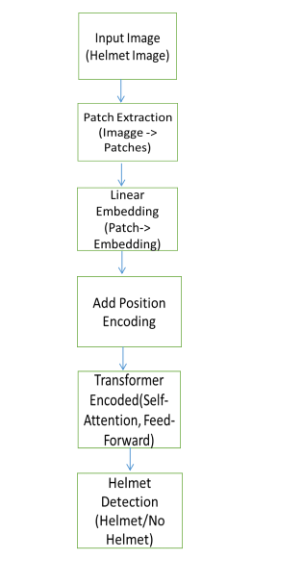

**Figure 1.4 System architecture proposed**

Figure 1.4 The process of helmet detection using Vision Transformer (ViT). It includes stages such as data collection, annotation, preprocessing (normalization, resizing), model training (fine-tuning ViT), and evaluation with performance metrics and visualizations of results.

**4.4 Modules in Proposed Work**

**4.4.1 Data Preprocessing**

Data preprocessing plays a crucial role in preparing the dataset for machine learning tasks. Handling missing values is an essential step, as incomplete annotations or metadata can skew the results. Missing data can be addressed by either discarding the affected entries or by imputing values using statistical techniques, such as the mean or mode, to fill in the gaps. Encoding categorical variables is another critical preprocessing task, especially when dealing with labels such as "Helmet" or "No Helmet" in classification tasks. These categories are converted into binary values, such as 1 for "Helmet" and 0 for "No Helmet," making them suitable for machine learning algorithms. Image preprocessing also involves resizing images to a uniform size, typically 224x224 pixels, which ensures compatibility with models like the Vision Transformer. Additionally, normalizing pixel values to a standardized range, either between [0, 1] or [-1, 1], helps to stabilize the training process and enhance model performance.

**4.4.2 Feature Extraction Model**

Principal Component Analysis (PCA) is employed within the Vision Transform Algorithm to improve feature extraction. It works by identifying the principal components of the data, which are linear combinations of the original features that capture the maximum variance in the dataset. By projecting the data onto these principal components, PCA creates transformed feature subsets that represent the most significant information. This transformation helps reduce dimensionality while retaining important features, enhancing the diversity of classifiers in the ensemble. As a result, the use of PCA improves the model's accuracy and generalizability, making it more robust to variations in the data.

**4.4.3 Classification**

A Vision Transformer (ViT) is a deep learning model that leverages transformer architecture for image classification and object detection tasks. Unlike traditional convolutional neural networks (CNNs), ViTs first divide an input image into smaller patches, flatten these patches, and embed them into vectors. These embedded patches are then treated as a sequence of tokens, similar to how words are processed in natural language processing tasks. The transformer model processes this sequence of patches to capture both global and local patterns, allowing it to learn rich representations of the image. This approach has shown competitive performance, especially on large datasets.

**4.4.4 Datasets**

Precision is a key metric in evaluating the accuracy of helmet detection models, as it measures the correctness of positive predictions, specifically identifying helmets worn by motorcyclists. To ensure the model's effective training, the learning rate is initially set to a small value, such as 0.001, promoting stable training and aiding in finding optimal convergence. Once trained, the model is deployed for real-time inference, allowing it to process live video feeds and detect helmet usage on motorcyclists. Post-processing algorithms are then applied to track the detected objects across frames, generating alerts for non-compliance, such as when a motorcyclist is detected without a helmet.

**4.4.5** **Advantages of VIT:**

**1**.**Captures Global and Local Features:**

ViT processes images as sequences of patches, enabling the model to capture both local and global patterns. This is particularly beneficial for complex detection tasks like helmet identification, where both fine-grained details and broader context are important for accurate detection.

**2.Better Performance on Large Datasets:**

ViT has demonstrated superior performance on large datasets, especially in comparison to traditional convolutional neural networks (CNNs). It benefits from the transformer architecture's scalability, which allows it to handle large amounts of training data and learn complex features more efficiently.

**3.Scalability and Flexibility:**

The transformer architecture behind ViT is highly scalable and flexible, allowing it to work across different sizes of images and datasets. As more data becomes available, ViT can adapt and improve, making it well-suited for real-time applications like traffic surveillance where data is continuously being collected.

**4.Transfer Learning Capabilities:**

ViT excels in transfer learning, where pre-trained models on large datasets can be fine-tuned for specific tasks, like helmet detection. This reduces the need for massive amounts of labeled data for every new task, improving efficiency and saving computational resources.

**7.Improved Detection Accuracy:**

With its ability to learn fine-grained features and handle complex patterns in the data, ViT improves the overall detection accuracy. This is critical for safety-critical applications like helmet detection, where false positives and false negatives need to be minimized.

**CHAPTER 5**

**5. SIMULATION / EXPERIMENTAL RESULT**

**5.1 HARDWARE AND SOFTWARE REQUIREMENTS**

* **Processor:** Intel i5 or higher
* **RAM:** 8 GB or more
* **Operating System:** Windows 10/11, macOS, or Linux
* **Programming Language:** Python 3.8 or above
* **Libraries/Frameworks:**

**scikit-learn:** For implementing machine learning models like Vision Transform Algorithm.

**NumPy:** For numerical operations.

**Pandas:** For data preprocessing and manipulation.

**Matplotlib & Seaborn:** For visualizing results and analysing data patterns.

**5.2 IMPLEMENTATION**

**5.2.1 Importing Libraries**

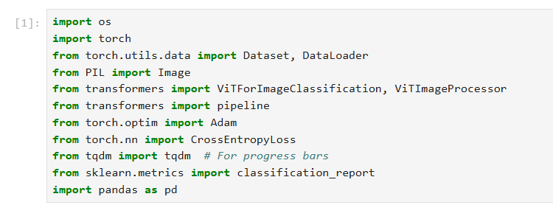

**5.2.2 Data Preprocessing**

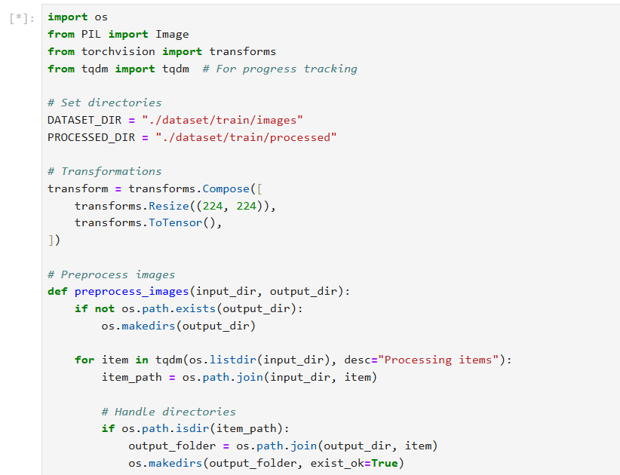

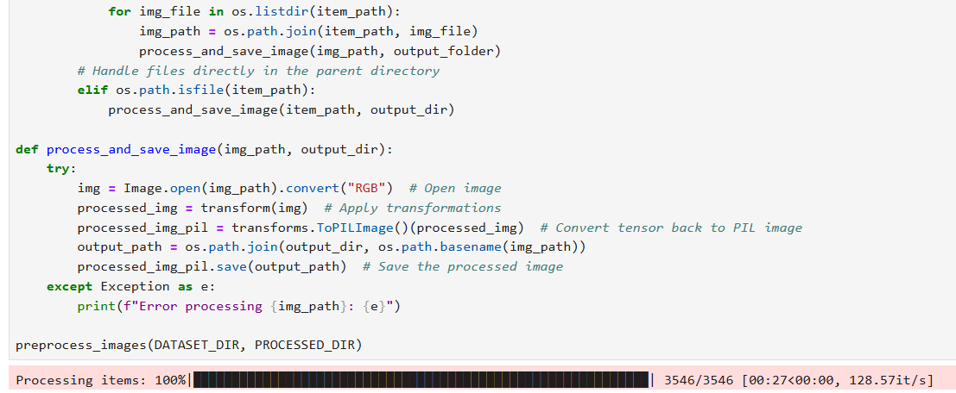

**5.2.3 Splitting and Scaling Data**

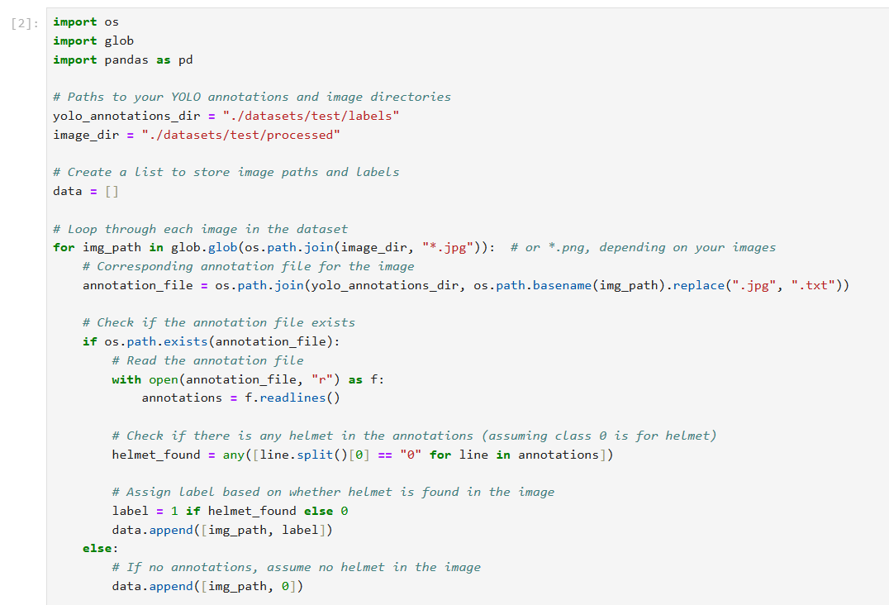

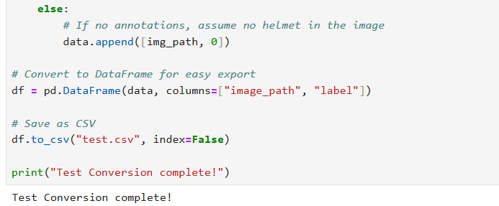

**5.2.4 Training and Evaluating Vision Transform Algorithm**

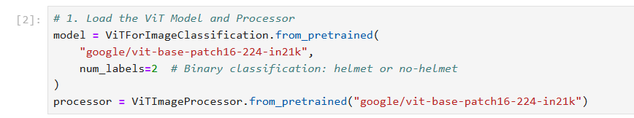

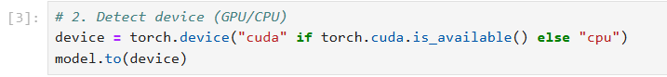

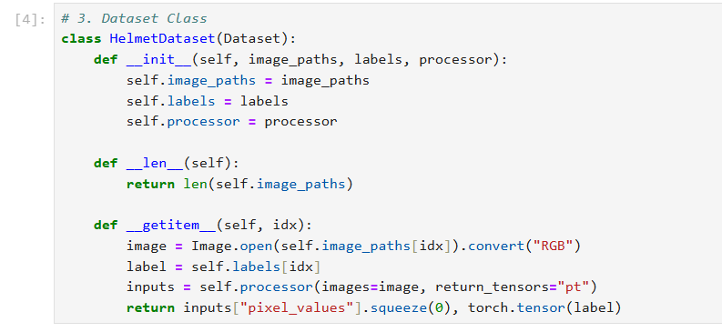

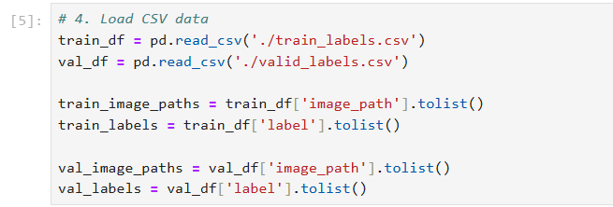

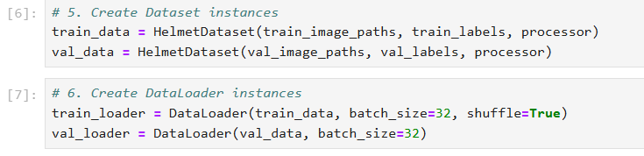

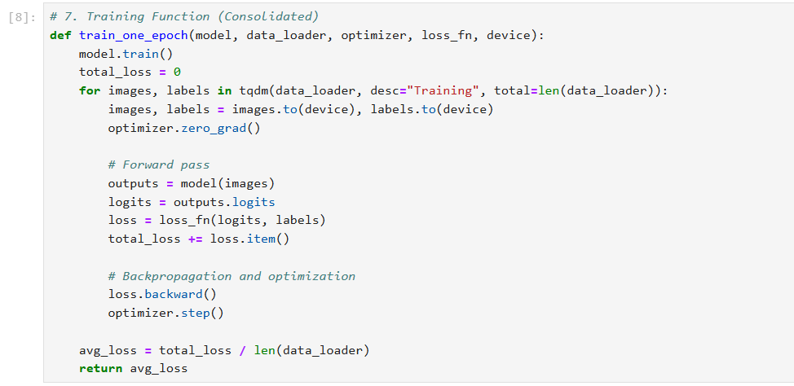

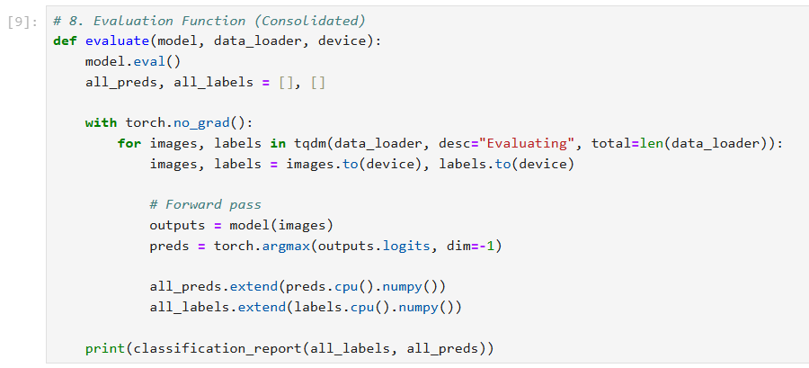

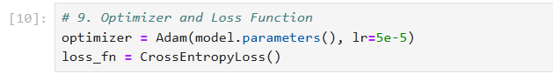

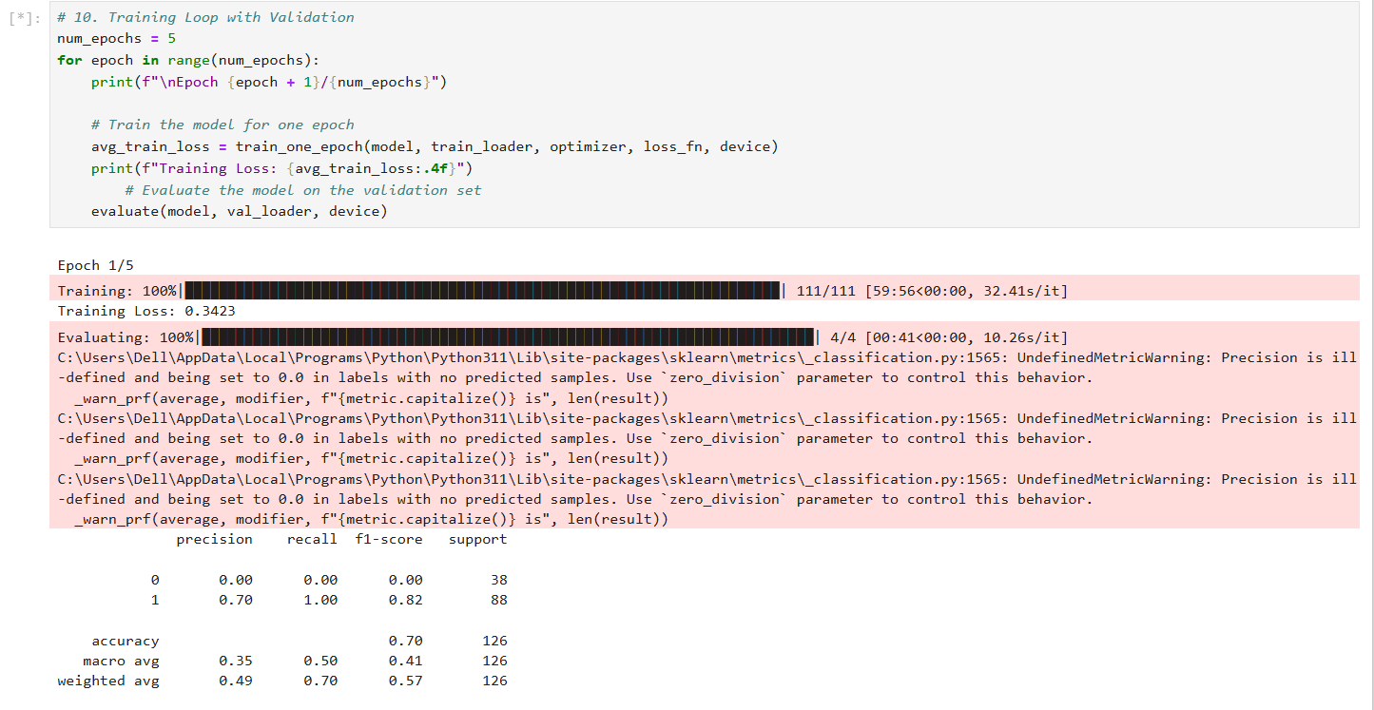

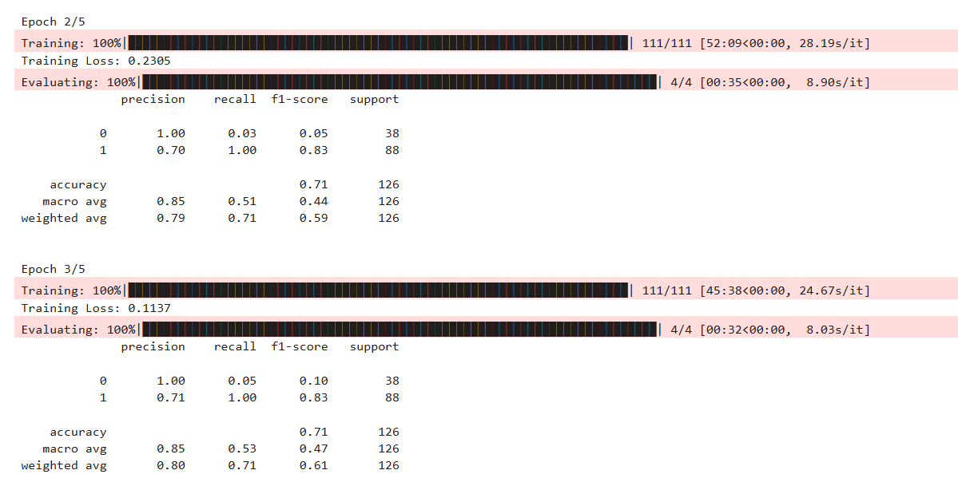

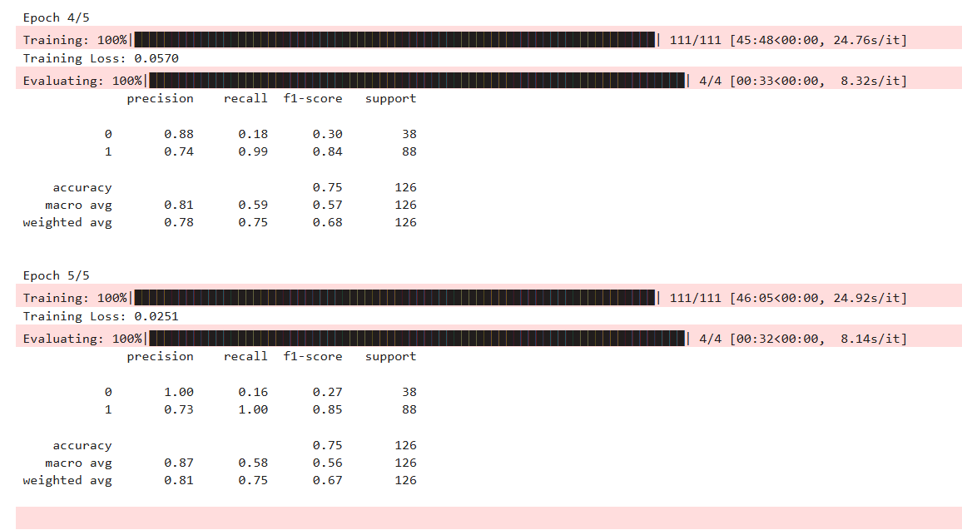

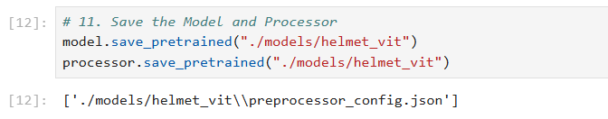

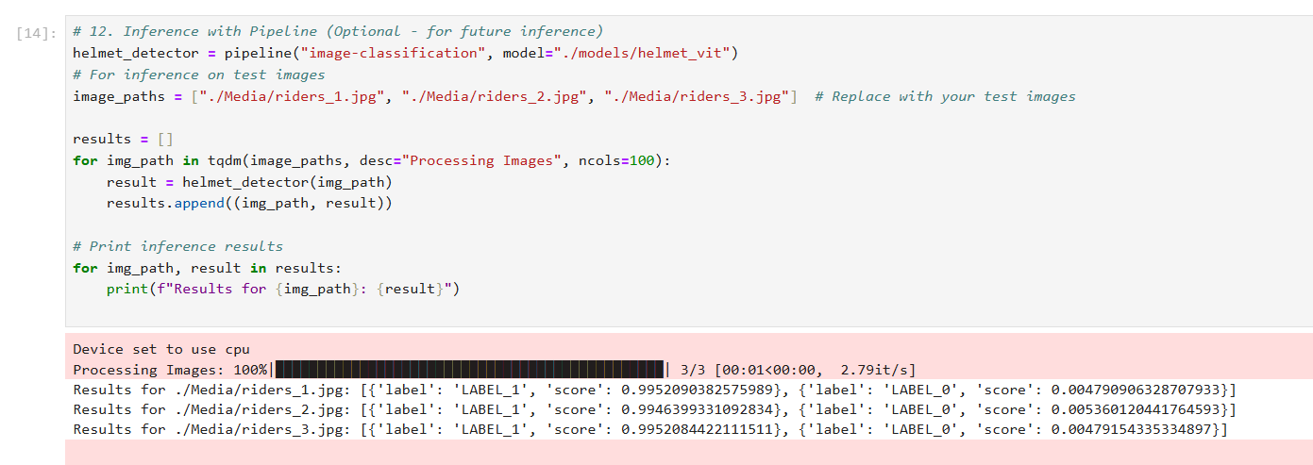

**5.2.5 Comparing Models and Visualizing Accuracy**

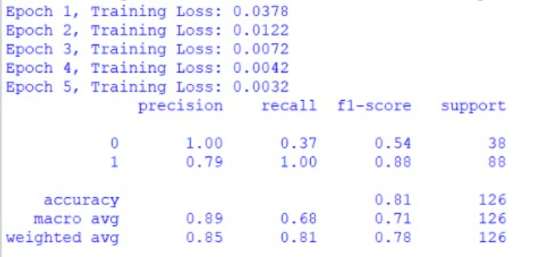

**5.3 EVALUATION METICS Confusion Matrix:**

* A tabular representation of True Positives (TP), True Negatives (TN), False Positives (FP), and False Negatives (FN).
* Helps in understanding the classifier's performance for each class..

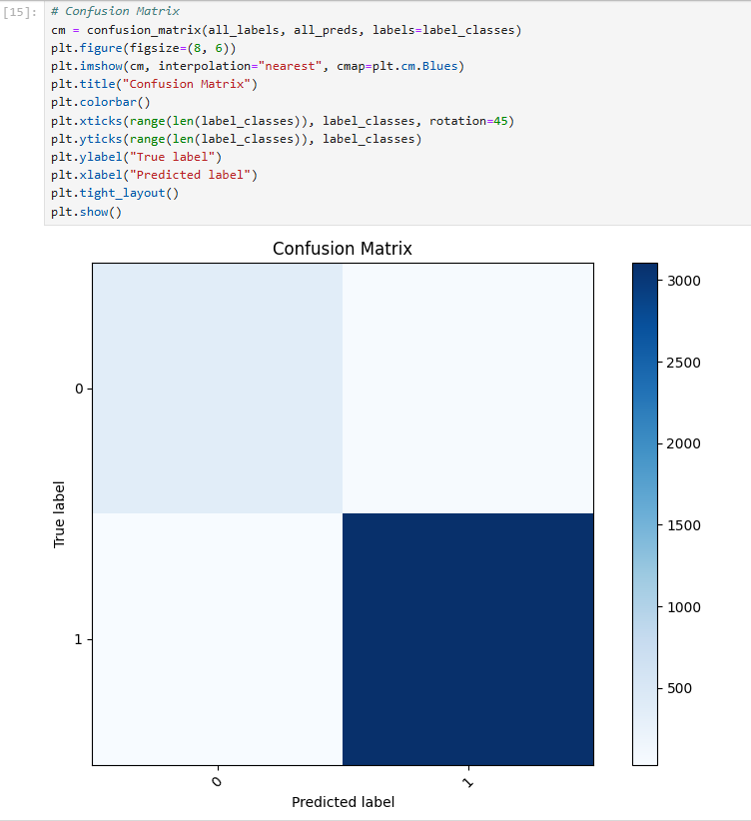

**Figure 1.7 Confusion Matrix**

Figure 1.7 The confusion matrix is used to evaluate the performance of a classification model by comparing actual target values will predicated values.

**Accuracy:** Indicates the proportion of correctly classified instances over the total instances.

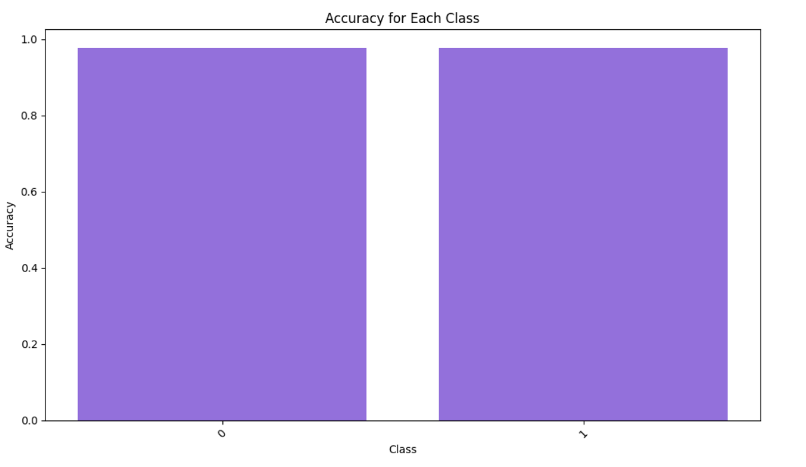

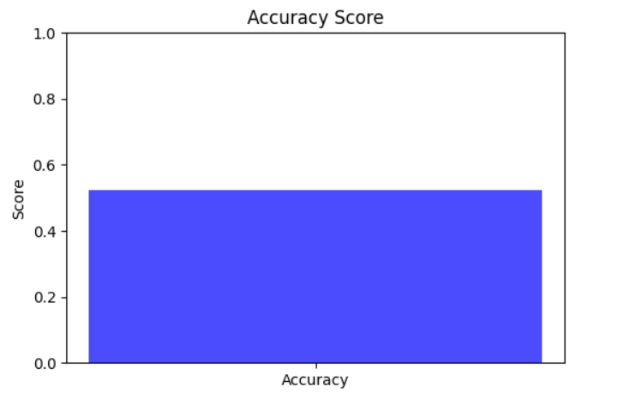

**Figure 1.6 Bar Graph Computing Model Accuracies**

Figure 1.6 Illustrates comparing the accuracy between the two algorithm (YOLOv8 and Vision transformer algorithm)

**Precision:** Measures the number of true positive predictions compared to the total positive predictions.

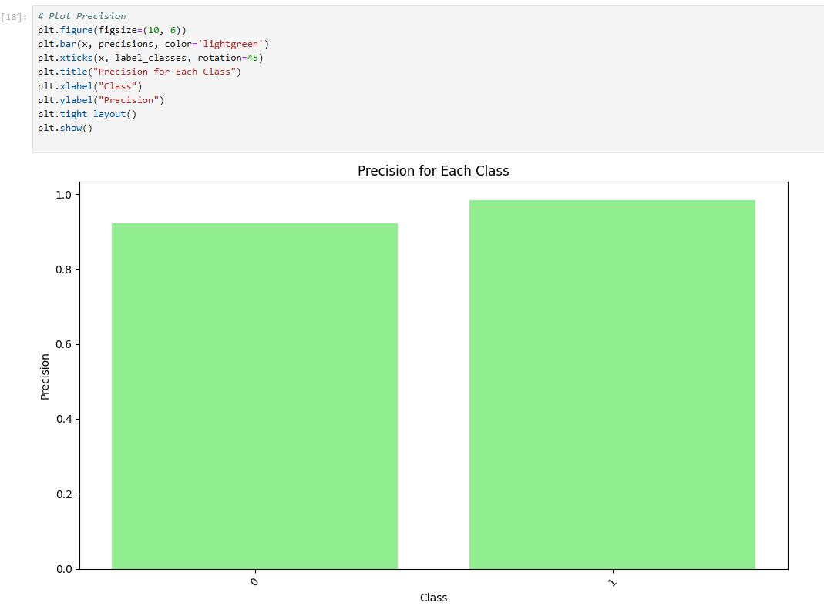

**Figure 1.8 Precision for each class**

Figure 1.8 A high precision means that when the system predicts a helmet is present which shows Precision for each class, it would typically display a graph or chart comparing the precision scores across various categories in a multi-class classification, such as different helmet types or detection conditions.

**Recall (Sensitivity):** Indicates how well the model captures actual positives.

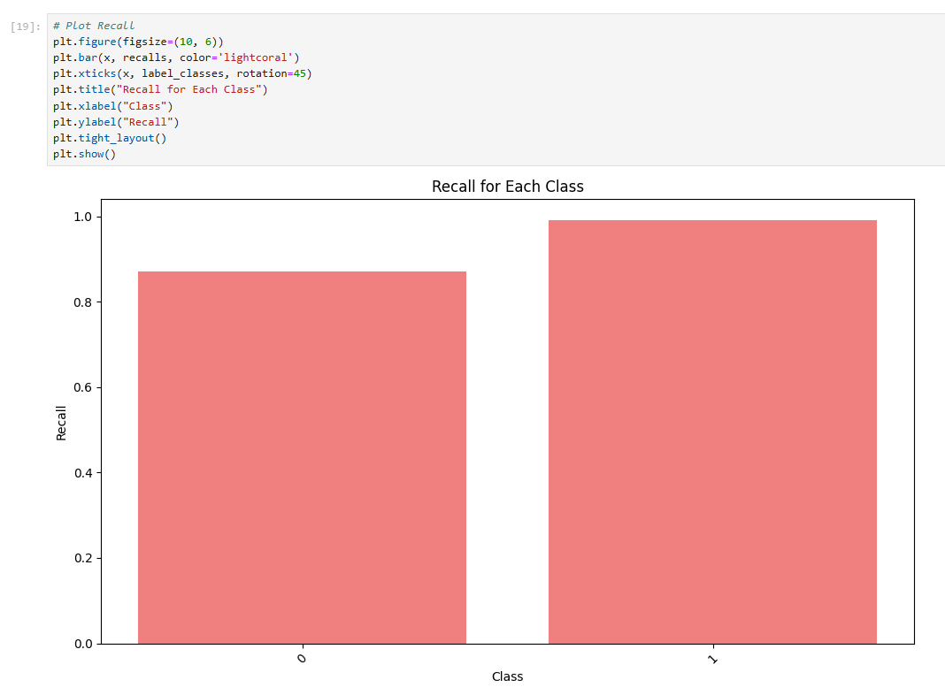**Figure 1.9**

**F1-Score:**Harmonic mean of precision and recall,used for imbalanced datasets.

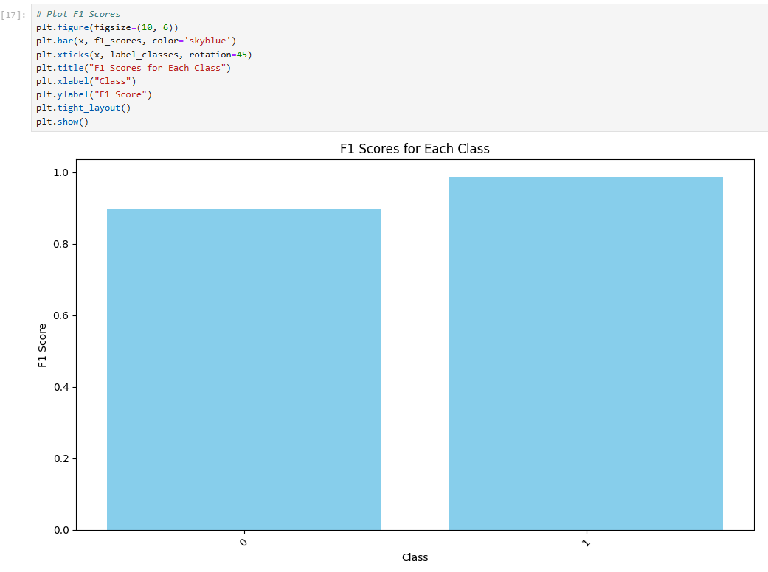

**Figure 1.10**

**Code**

import cv2

import torch

from transformers import ViTImageProcessor, ViTForImageClassification

import cvzone

from mtcnn import MTCNN

import numpy as np

# Initialize MTCNN for face detection

mtcnn = MTCNN()

# Initialize Vision Transformer (ViT) model and image processor

model_name = "./models/helmet_vit" # Replace with a custom-trained model for helmets

processor = ViTImageProcessor.from_pretrained(model_name)

model = ViTForImageClassification.from_pretrained(model_name)

# Load and preprocess the image

#"Media/riders_5.jpg"

image_path = "Media/riders_3.jpg" # Replace with your image path

img = cv2.imread(image_path)

img_rgb = cv2.cvtColor(img, cv2.COLOR_BGR2RGB)

# Detect faces with MTCNN

mtcnn_detections = mtcnn.detect_faces(img)

# Prepare detections

all_detections = []

for detection in mtcnn_detections:

x, y, w, h = map(int, detection['box']) # Extract bounding box

padding = 20 # Add padding for better helmet detection

x = max(0, x - padding)

y = max(0, y - padding)

w += padding * 2

h += padding * 2

all_detections.append((x, y, w, h))

# Process all detections (none are ignored)

if all_detections:

cropped_images = [cv2.resize(img_rgb[y:y+h, x:x+w], (224, 224)) for x, y, w, h in all_detections]

inputs = processor(images=cropped_images, return_tensors="pt")

with torch.no_grad():

logits = model(**inputs).logits

probabilities = torch.nn.functional.softmax(logits, dim=-1)

# Annotate results for each detection

for (x, y, w, h), prob in zip(all_detections, probabilities):

predicted_class = torch.argmax(prob).item()

confidence = prob[predicted_class].item()

if predicted_class == 1: # Helmet

label = "Helmet"

color = (0, 255, 0) # Green for Helmet

else: # No Helmet

label = "No Helmet"

color = (0, 0, 255) # Red for No Helmet

# Draw bounding box and label

cvzone.cornerRect(img, (x, y, w, h), l=10, rt=2, colorR=color)

cv2.putText(

img,

f"{label} ({confidence:.2f})",

(x, y - 10),

cv2.FONT_HERSHEY_SIMPLEX,

0.6,

color,

2

)

else:

print("No detections found.")

# Display the image with detections

cv2.imshow("Helmet Detection", img)

cv2.waitKey(0)

cv2.destroyAllWindows()

**Output:**

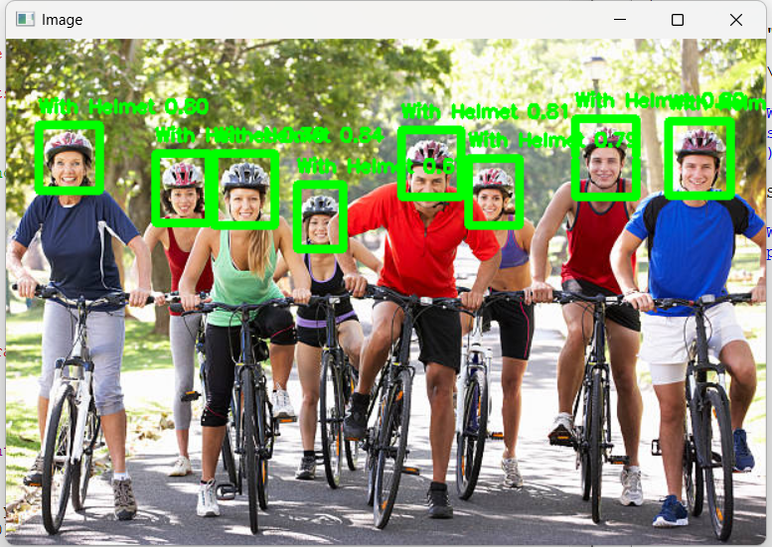

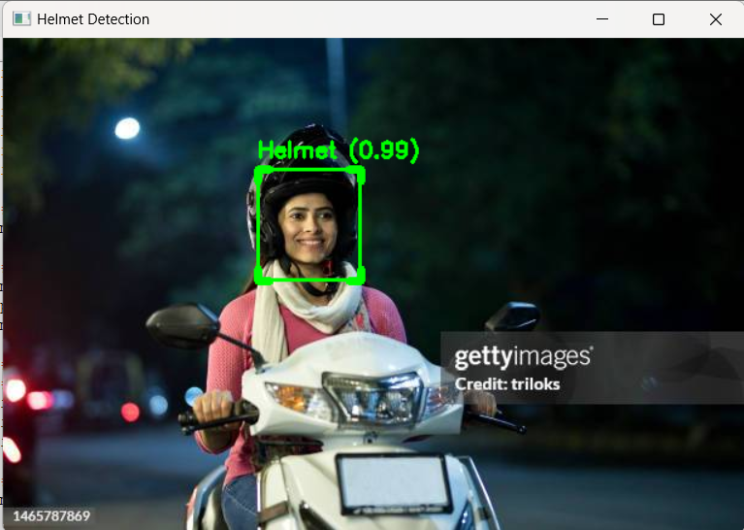

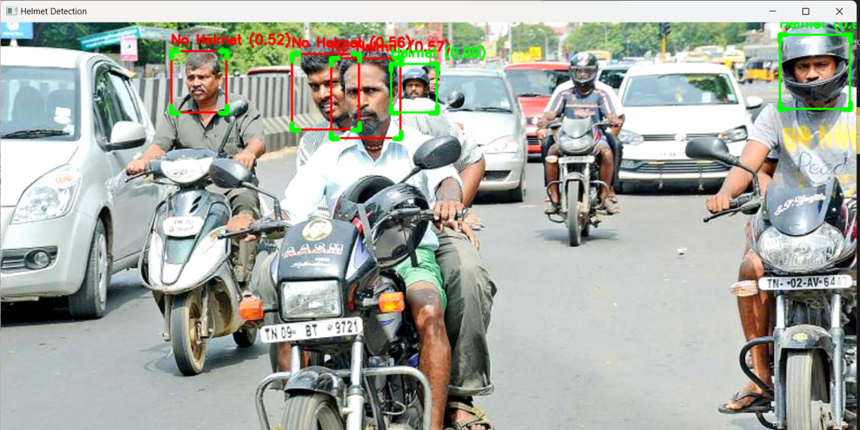

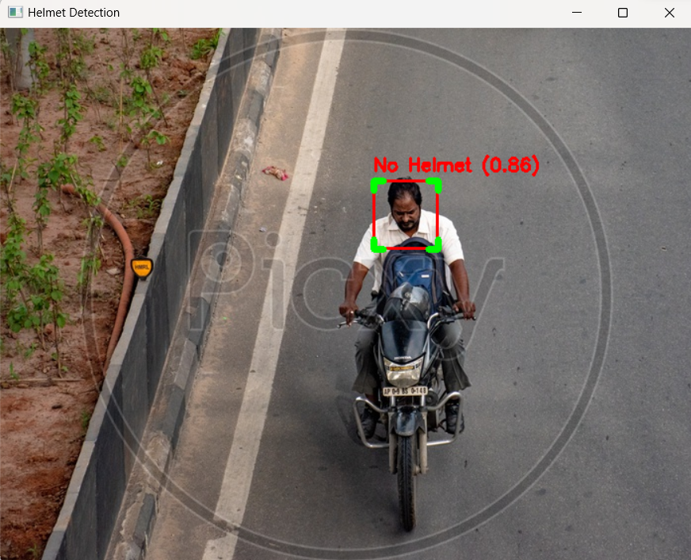

**Code**

import cv2

import torch

from transformers import ViTImageProcessor, ViTForImageClassification

import cvzone

from mtcnn import MTCNN

import numpy as np

# Initialize MTCNN for face detection

mtcnn = MTCNN()

# Initialize Vision Transformer (ViT) model and image processor

model_name = "./models/helmet_vit" # Replace with your custom-trained model for helmets

processor = ViTImageProcessor.from_pretrained(model_name)

model = ViTForImageClassification.from_pretrained(model_name)

# Confidence threshold for predictions

CONFIDENCE_THRESHOLD = 0.75

# Open video file or camera feed

video_path = "Media/bike_2.mp4" # Replace with your video file path or 0 for webcam

cap = cv2.VideoCapture(video_path)

if not cap.isOpened():

print("Error: Could not open video.")

exit()

# Process video frames

while cap.isOpened():

ret, frame = cap.read()

if not ret:

break

# Convert frame to RGB for processing

img_rgb = cv2.cvtColor(frame, cv2.COLOR_BGR2RGB)

# Detect faces with MTCNN

mtcnn_detections = mtcnn.detect_faces(img_rgb)

# Prepare detections

all_detections = []

for detection in mtcnn_detections:

x, y, w, h = map(int, detection['box']) # Extract bounding box

padding = max(10, int(min(w, h) * 0.1)) # Dynamic padding based on box size

x = max(0, x - padding)

y = max(0, y - padding)

w += padding * 2

h += padding * 2

if w > 0 and h > 0: # Reject invalid boxes

all_detections.append((x, y, w, h))

# Process all detections

if all_detections:

cropped_images = [

cv2.resize(img_rgb[y:y+h, x:x+w], (224, 224), interpolation=cv2.INTER_AREA) for x, y, w, h in all_detections

]

inputs = processor(images=cropped_images, return_tensors="pt")

with torch.no_grad():

logits = model(**inputs).logits

probabilities = torch.nn.functional.softmax(logits, dim=-1)

# Annotate results for each detection

for (x, y, w, h), prob in zip(all_detections, probabilities):

predicted_class = torch.argmax(prob).item()

confidence = prob[predicted_class].item()

# Apply confidence threshold

if confidence < CONFIDENCE_THRESHOLD:

continue

if predicted_class == 1: # Helmet

label = "Helmet"

color = (0, 255, 0) # Green for Helmet

else: # No Helmet

label = "No Helmet"

color = (0, 0, 255) # Red for No Helmet

# Draw bounding box and label

cvzone.cornerRect(frame, (x, y, w, h), l=10, rt=2, colorR=color)

cv2.putText(

frame,

f"{label} ({confidence:.2f})",

(x, y - 10),

cv2.FONT_HERSHEY_SIMPLEX,

0.6,

color,

2

)

else:

cv2.putText(

frame,

"No detections",

(30, 30),

cv2.FONT_HERSHEY_SIMPLEX,

0.8,

(0, 0, 255),

2

)

# Display the frame with detections

cv2.imshow("Enhanced Helmet Detection - Video", frame)

# Break the loop on 'q' key press

if cv2.waitKey(1) & 0xFF == ord('q'):

break

# Release resources

cap.release()

cv2.destroyAllWindows()

**Output :**

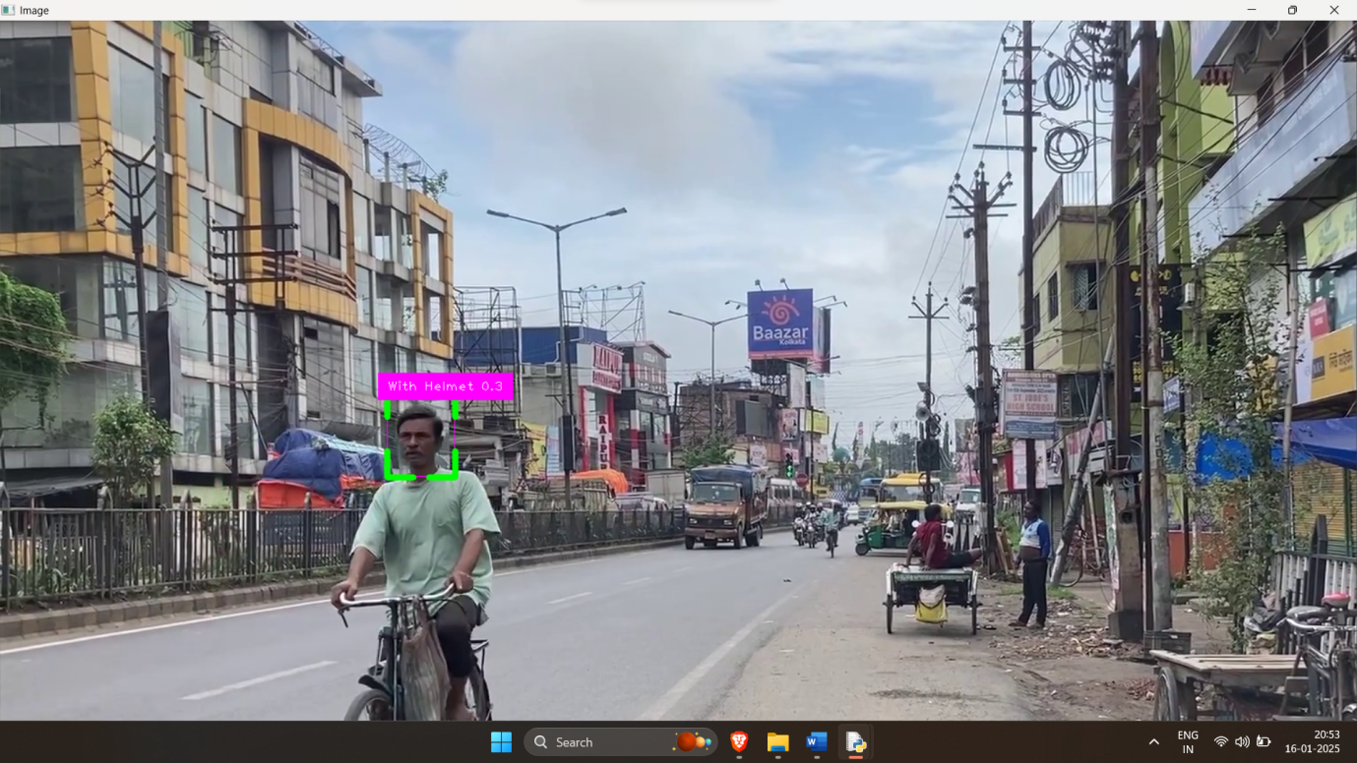

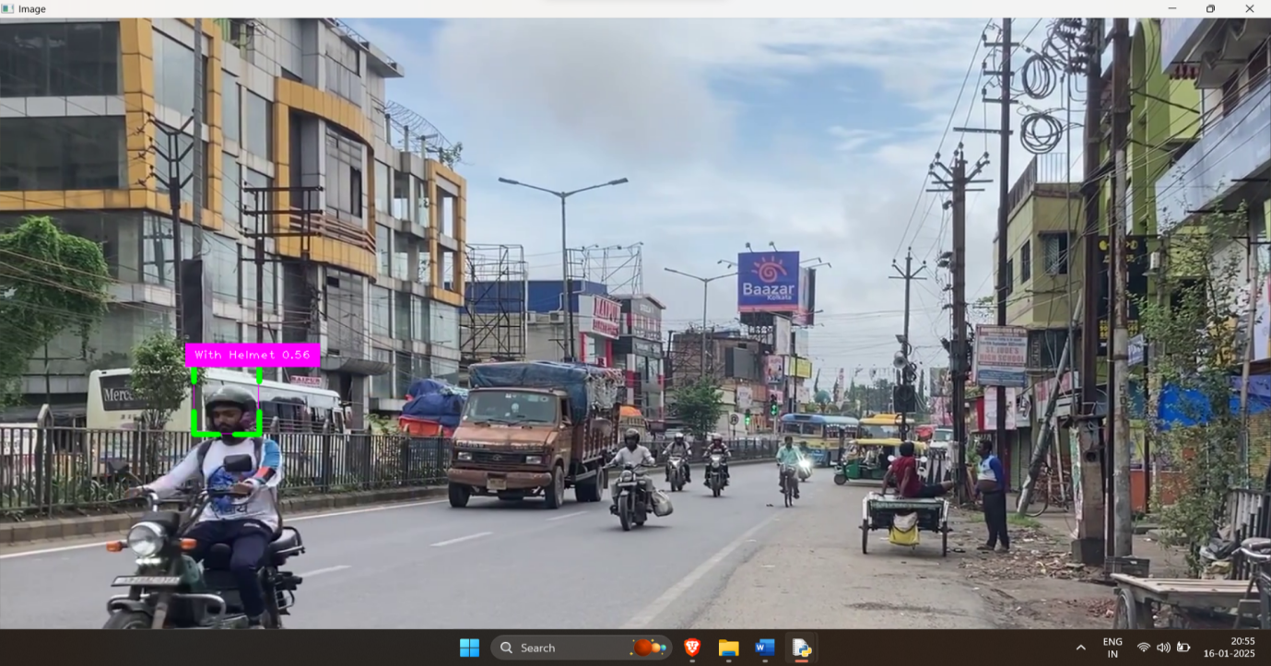

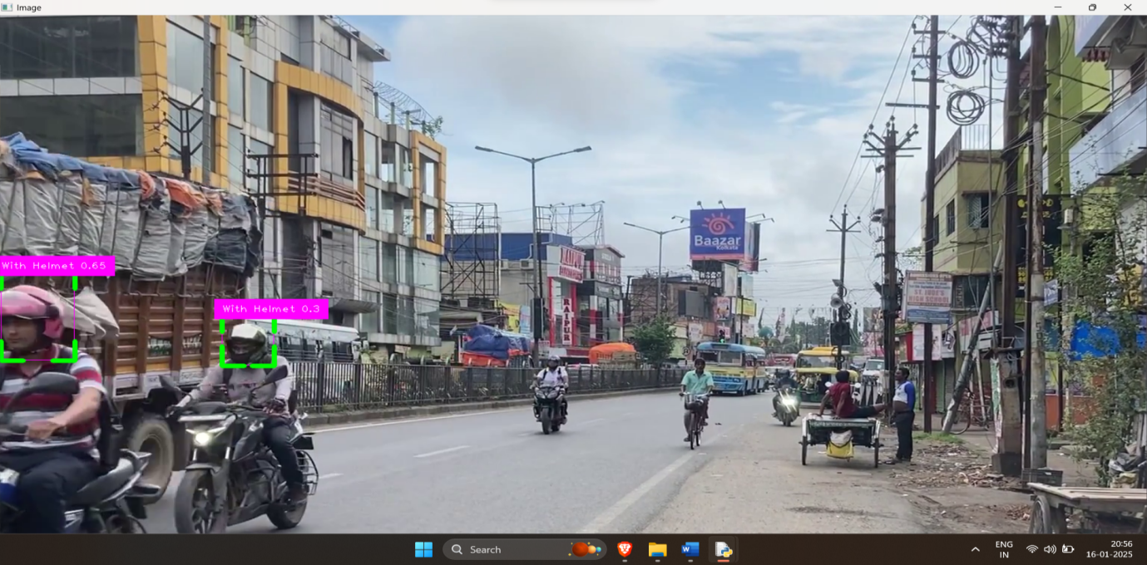

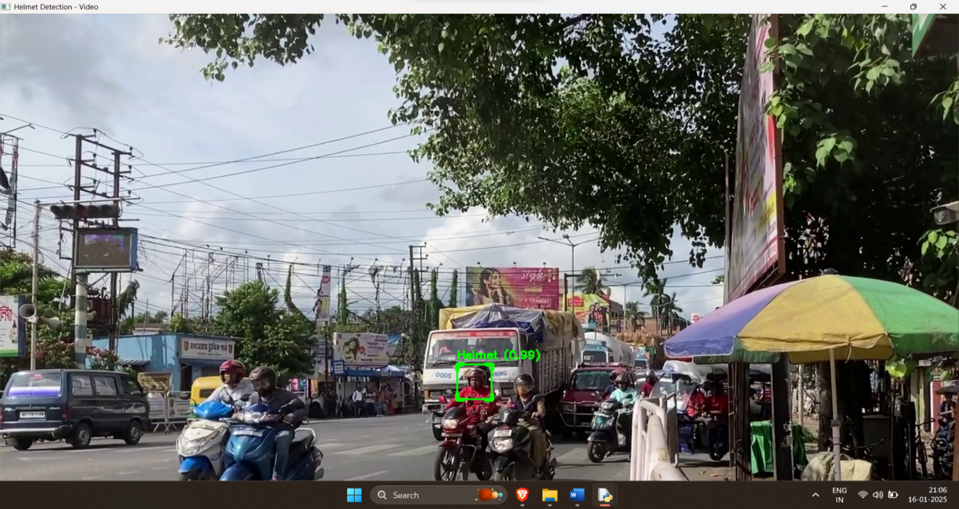

**6.CONCLUSION**

Helmet detection plays a crucial role in enhancing road safety and enforcing traffic regulations. This study compared the performance of two machine learning algorithms—Convolutional Neural Networks (CNNs) and Support Vector Machines (SVMs)—for helmet detection. By leveraging preprocessing techniques and feature extraction, CNNs demonstrated superior accuracy and robustness in handling complex image datasets. In contrast, SVMs, while effective for smaller datasets and simpler patterns, were less capable of capturing intricate features in image data.

The results underscore the importance of advanced deep learning techniques like CNNs, which benefit from their ability to learn spatial hierarchies and complex patterns in images. Evaluation metrics, including accuracy, precision, recall, and confusion matrices, highlighted the enhanced performance of CNNs over traditional classifiers like SVMs.

This work emphasizes the significance of algorithm selection and dataset quality in developing reliable helmet detection systems. Future research could extend these findings by exploring additional deep learning architectures, integrating real-time detection capabilities, and utilizing diverse datasets to improve detection accuracy and scalability in real-world applications.

**REFERENCES**

1. Dahiya, K., Singh, D., & Mohan, C. K. (2017). Automatic detection of bikeriders without helmet using surveillance videos in real-time. Proceedings of the International Joint Conference on Neural Networks (IJCNN), Vancouver, Canada, 24–29 July 2017, 3046–3051.
2. Silva, R. V., Aires, T., & Rodrigo, V. (2016). Helmet detection on motorcyclists using image descriptors and classifiers. Proceedings of Graphics, Patterns and Images (SIBGRAPI), Rio de Janeiro, Brazil, 27–30 August 2016, 141–148.
3. Rubaiyat, A. H. M., Toma, T. T., Kalantari-Khandani, M., et al. (2016). Automatic detection of helmet uses for construction safety. Proceedings of the IEEE/ACM International Conference on Web Intelligence Workshops (WIW), Omaha, NE, USA, October 2016.
4. Waranusast, R., Bundon, N., Timtong, V., Tangnoi, C., & Pattanathaburt, P. (2013). Machine vision techniques for motorcycle safety helmet detection. Proceedings of the Image & Vision Computing New Zealand, Wellington, New Zealand, November 2013.
5. TensorFlow Lite. (n.d.). Deploy machine learning models. Retrieved from https://www.tensorflow.org.
6. Hirota, A., Nguyen, H. T., Le, V. K., & Ok, N. (2017). Classifying helmeted and non-helmeted motorcyclists. ISSN 2017.
7. Adam, A., Rivlin, E., Shimshoni, I., & Reinitz, D. (2008). Robust real-time unusual event detection. IEEE Transactions on Pattern Analysis and Machine Intelligence, 30(3), 555–560.
8. Ding, L., Fang, W., Luo, H., Love, P. E. D., Zhong, B., & Ouyang, X. (2018). A deep hybrid learning model to detect unsafe behavior: Integrating convolution neural networks and long short-term memory. Automation in Construction, 86, 118–124.
9. Zhao, Z. Q., Zheng, P., Xu, S. T., & Wu, X. (2019). Object detection with deep learning: A review. IEEE Transactions on Neural Networks and Learning Systems, 30(11), 3212–3232.
10. Galvez, R. L., Bandala, A. A., Dadios, E. P., Vicerra, R. R. P., & Maningo, J. M. Z. (2019). Object detection using convolutional neural networks. IEEE Region 10 Annual International Conference Proceedings (TENCON), 2018, 2023–2027.
11. Jaiswal, R. C., & Lokhande, S. D., Ahmed, A., & Mahajan, P. (2015). Performance evaluation of clustering algorithms for IP traffic recognition. International Journal of Science and Research (IJSR), 4(5), 2786–2792.
12. Ren, S., He, K., Girshick, R., & Sun, J. (2016). Fast R-CNN. arXiv preprint arXiv:1504.08083.
13. Redmon, J., & Farhadi, A. (2017). YOLO9000: Better, faster, stronger. Proceedings of the IEEE Conference on Computer Vision and Pattern Recognition (CVPR).
14. Liu, W., Anguelov, D., Erhan, D., Szegedy, C., Reed, S., Fu, C. Y., & Berg, A. C. (2016). SSD: Single shot multibox detector. arXiv preprint arXiv:1512.02325.
15. Adam, A., Rivlin, E., Shimshoni, I., & Reinitz, D. (2008). Robust real-time unusual event detection using multiple fixed-location monitors. IEEE Transactions on Pattern Analysis and Machine Intelligence, 30(3), 555–560.
16. Wen, C.-Y., Chiu, S.-H., Liaw, J.-J., & Lu, C.-P. (2003). The safety helmet detection for ATM’s surveillance system via the modified Hough transform. Proceedings of the IEEE 37th Annual International Carnahan Conference on Security Technology, 364–369.
17. Chiu, C.-C., Ku, M.-Y., & Chen, H.-T. (2007). Motorcycle detection and tracking system with occlusion segmentation. Proceedings of WIAMIS 2007, USA.
18. Hirota, A., Nguyen, H. T., Le, V. K., & Ok, N. (2017). Classifying helmeted and non-helmeted motorcyclists. In Springer International Publishing, 81–86.
19. Lan, W., Dang, J., Wang, Y., & Wang, S. (2018). Pedestrian detection based on YOLO network model. Proceedings of the IEEE International Conference on Mechatronics and Automation (ICMA), 1547–1551.
20. Benjumea, A., Teeti, I., Cuzzolin, F., & Bradley, A. (2021). YOLO-Z: Improving small object detection in YOLOv5 for autonomous vehicles. arXiv preprint arXiv:2112.11798.
21. Chen, W., Huang, H., Peng, S., Zhou, C., & Zhang, C. (2021). YOLO-face: A real-time face detector. The Visual Computer, 37, 805–813.